

Here's a step-by-step guide to check whether your Aadhaar has been linked with your bank account.
1. Visit the Aadhaar website - www.uidai.gov.in
2. Click on 'Check Aadhaar/Bank Account Linking Status'
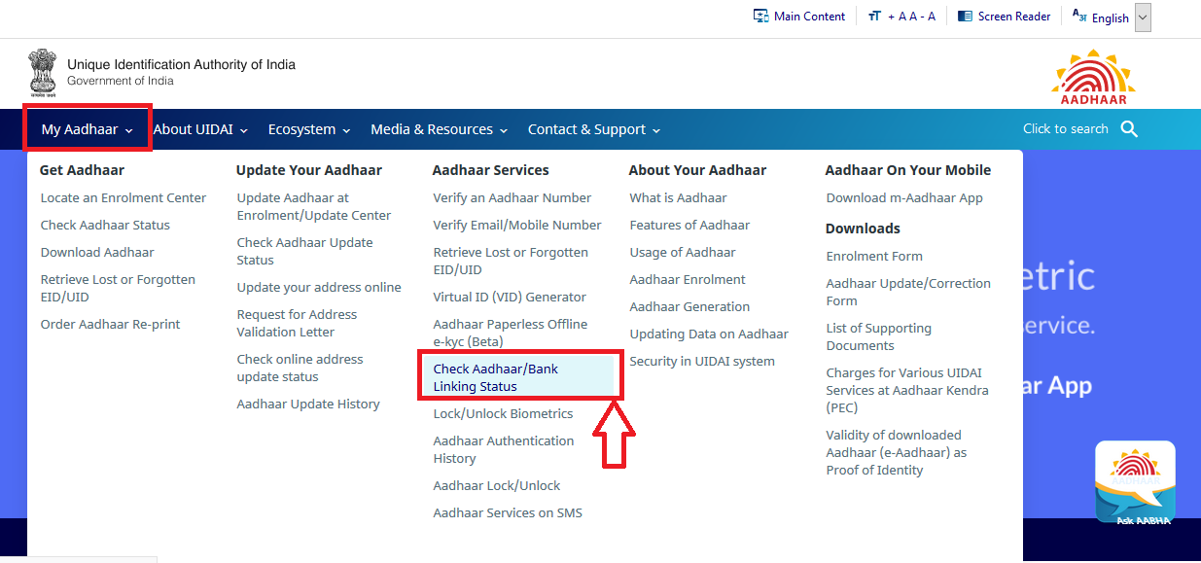

3. Enter your 12-digit Aadhaar number or 16 digit Virtual ID and security code as shown
on the screen ..
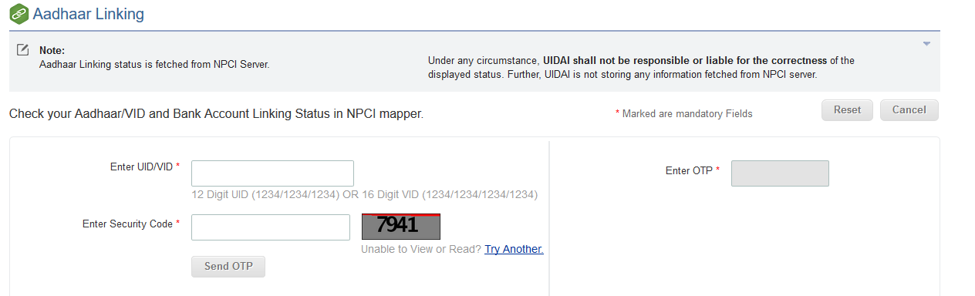

4. Enter OTP and click on Login button
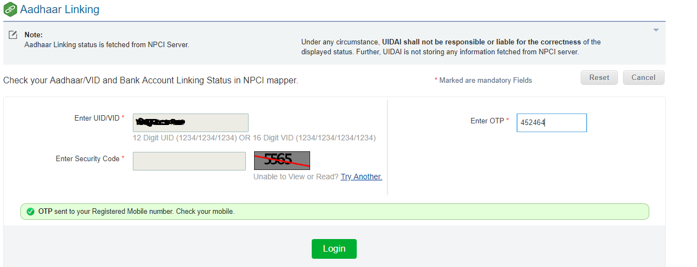

5. Below screen will be displayed if bank is linked with Aadhaar Number along
with Bank Name.
